DAYS 18-19
Suricata and Wazuh Integration
// 01 OVERVIEW & SCOPE

Through Day 17, Suricata and Wazuh operated as two independent tools writing to two independent log files. Days 18 and 19 connect them: the Wazuh agent on Kali is configured to monitor Suricata's eve.json the same way it monitors any other log source. When Suricata writes a new alert, the agent forwards it to the Wazuh Manager, which decodes it using the built-in Suricata decoder and rule set, and the result is indexed and searchable in the same dashboard as host-based FIM, authentication, and PAM events.
The value of this integration is correlation. A network-level event (a scan, an exploit attempt) and a host-level event (a file change, a new account, a privilege escalation) happening from the same source in the same time window tell a more complete story together than either does alone.
$ Deliverables in This Report
- The localfile block added to the Kali agent's ossec.conf
- Confirmation that Suricata alerts are decoded and indexed on the Manager
- Dashboard screenshots showing custom rule alerts (sids 1000001-1000003) arriving via the Suricata decoder
- A correlation analysis pairing a Suricata network alert with a Wazuh host-based alert from the same activity

// 02 AGENT CONFIGURATION — KALI
$ localfile Block Added to ossec.conf
The only configuration change required on the agent side. This tells the Wazuh agent to treat eve.json as a JSON-formatted log source and forward new entries to the Manager as they're written.
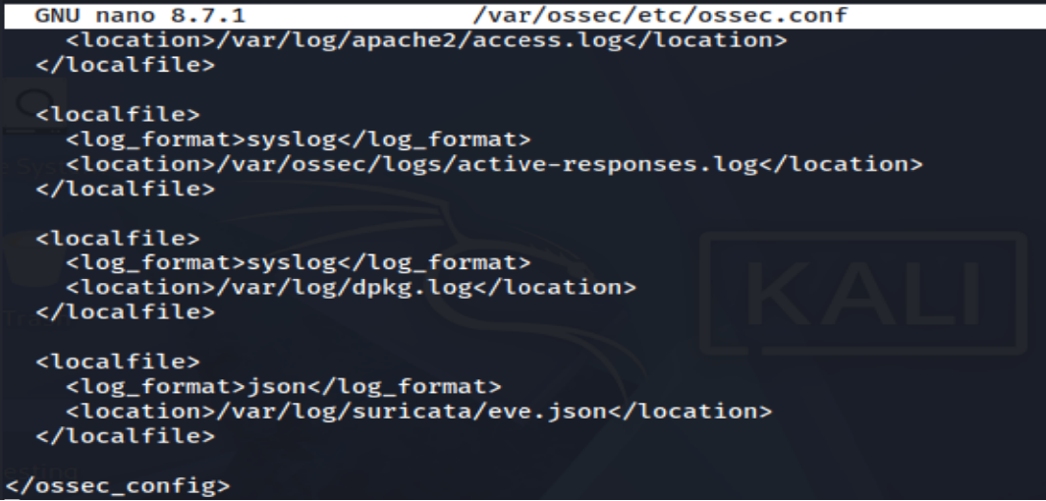
File permissions on eve.json were confirmed as world-readable (644, owned by root) to rule out a silent permission-based read failure. After a full stop/start of the wazuh-agent service (a config reload alone was not sufficient to pick up the new block reliably), the agent log confirmed active monitoring:
The Wazuh dashboard's Agents view was checked to confirm the Kali agent remained in an Active state throughout the restart, with no disconnect beyond the brief expected reconnection window.
// 03 MANAGER-SIDE DECODER VERIFICATION

The Wazuh Manager ships with a built-in Suricata decoder and rule set — no manual rule authoring was required on the Manager side. This was confirmed indirectly: rather than inspecting the ruleset files directly, the first Suricata-origin alert to appear in the dashboard confirmed the decoder chain was active end to end.
$ First Confirmed Suricata Event in Wazuh
A default Emerging Threats alert (not one of the custom rules) was the first event to surface, confirming the full pipeline — Suricata to eve.json, eve.json to agent, agent to Manager, Manager decode to indexed dashboard event — was functioning correctly before custom rule traffic was re-tested.
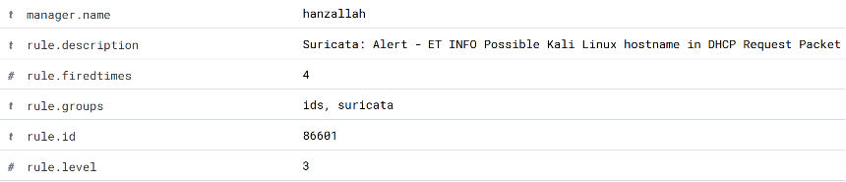
First Suricata-decoded event confirmed in Wazuh Security Events — rule group 86xxx is the Suricata decoder range

// 04 CUSTOM RULE ALERTS IN WAZUH

With the pipeline confirmed, all three custom Suricata rules from Day 17 were re-triggered and searched for in the Wazuh dashboard using the alert signature field, which only populates once at least one Suricata-origin event has been indexed.
Search: data.alert.signature: "CUSTOM*"
- sid 1000001 — CUSTOM Nmap SYN Scan Detected — triggered via nmap -sS 192.168.56.10
- sid 1000002 — CUSTOM HTTP Directory Traversal Attempt — triggered via curl --path-as-is against the traversal payload
- sid 1000003 — CUSTOM ICMP Flood Detected — triggered via sudo ping -f -c 200 192.168.56.10
Each alert appears in the dashboard tagged with rule ID 86601 (the generic Suricata alert decoder rule) with the specific custom message preserved in the data.alert.signature field, distinguishing it from native Wazuh host-based rules at a glance.
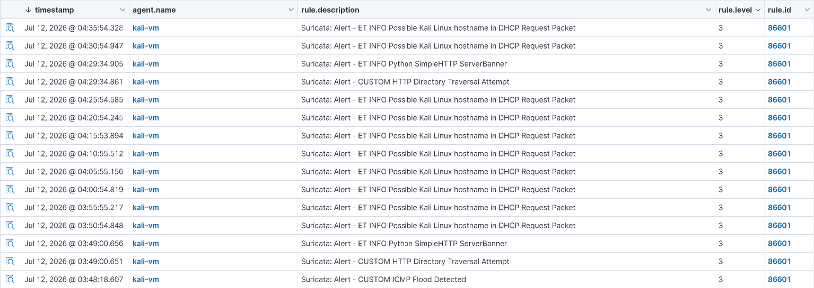
Suricata alerts decoded and indexed in Wazuh, fields parsed from eve.json
// 05 CORRELATION EXERCISE

To demonstrate the combined value of network and host visibility, a two-stage attack sequence was run from Kali against the Ubuntu Server, generating one Suricata network alert and one Wazuh host-based alert from the same source within the same time window.
$ Stage 1 — Network Reconnaissance
An Nmap SYN scan was run from Kali against the Ubuntu Server. This generated a Suricata alert (sid 1000001, CUSTOM Nmap SYN Scan Detected) forwarded through the integration and visible in Wazuh under rule 86601.

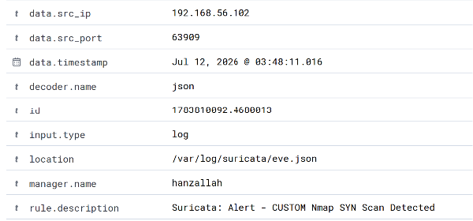
Suricata alert in Wazuh — Nmap SYN scan from 192.168.56.102

$ Stage 2 — Host-Level Follow-Through
Immediately after, a file was created directly in /etc on the Ubuntu Server, simulating a persistence artifact an attacker might drop after gaining access. This triggered a Wazuh File Integrity Monitoring (syscheck) alert on the Ubuntu agent.

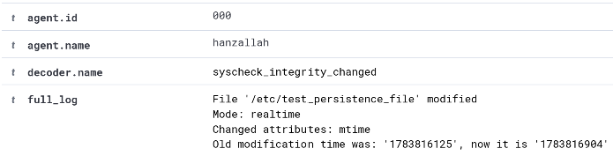
Wazuh FIM alert — new file created in /etc on Ubuntu Server

